* **CODES OF WEBSITE**
* **Main Page Code (HTML)**

<!DOCTYPE html>

<html>

<head>

<meta charset="utf-8">

<meta name="viewport" content="width=device-width, initial-scale=1">

<title>WELCOME TO GOVERNMENT POLYTECHNIC MALVAN </title>

<link rel="stylesheet" type="text/css" href="style.css">

</head>

<body style="background-color: #FFFFE0;" >

<div class="main">

<div class="header"></div>

<marquee> <b>Welcome to the Website of Government Polytechnic Malvan! </marquee>

<div class="navigationbar">

<ul>

<li><a href="index.html" >HOME</a></li>

<li><a href="C:\Users\hp\Desktop\MicroProject\Files\Mandatory_Disclosure_GPM_190221.pdf">ABOUT US</a> </li>

<li><a href="C:\Users\hp\Desktop\MicroProject\Files\Admissionintake.pdf">ADDMISSION</a> </li>

<li><a href="departments.html">DEPARTMENTS</a> </li>

<li><a href="facilities.html">FACILITIES</a> </li>

<li><a href="contact.html">CONTACT US</a> </li>

</ul>

</div>

<div class="bodypart">

<div class="slideshow"><a href="C:\Users\hp\Desktop\MicroProject\slideshow\ezgif.com-gif-maker.gif"><img width="400px" height="400px" src="C:\Users\hp\Desktop\MicroProject\images\HD_transparent_picture.png"></a></div>

<div class="photo" >

<div class="column" align="center">

<div class="card">

<a href="C:\Users\hp\Desktop\MicroProject\slideshow\download (1).jpg" ><img src="C:\Users\hp\Desktop\MicroProject\slideshow\download (1).jpg" alt="Shri. Pramod Naik" style="width:54%"></a>

<div class="container">

<h4> Shri. Pramod Naik</h4>

<p>Director,MSBTE </p>

</div>

</div>

</div>

<div class="column" align="center">

<div class="card">

<a href="C:\Users\hp\Desktop\MicroProject\slideshow\download.jpg"><img src="C:\Users\hp\Desktop\MicroProject\slideshow\download.jpg" alt="Dr. Vinod Mohitkar" style="width:67%"></a>

<div class="container" style="padding: 2px;">

<h4>Dr. Vinod Mohitkar</h4>

<p>Director, DTE</p>

</div>

</div>

</div>

<div class="column" align="center" style="padding: 1px;padding-bottom: 0px;">

<div class="card">

<a href="C:\Users\hp\Desktop\MicroProject\slideshow\rastogi.jpg"><img src="C:\Users\hp\Desktop\MicroProject\slideshow\rastogi.jpg" alt="Shri. Vikas Chandra Rastogi" style="width:67%"></a>

<div class="container">

<h4>Shri. Vikas Chandra Rastogi</h4>

<p>Hon.Secretary,H&amp;TE</p>

</div>

</div>

</div>

<div class="row">

<div class="column" >

<div class="card">

<a href="C:\Users\hp\Desktop\MicroProject\slideshow\images.jpg" ><img src="C:\Users\hp\Desktop\MicroProject\slideshow\images.jpg" alt="Shri. Chandrakant Patil" style="width:100%"></a>

<div class="container" style="padding-bottom: 2px;padding: 3px;">

<h4 style="padding-bottom: 0px;">Shri. Chandrakant Patil</h4>

<p>Honourable Minister <br>&nbsp;Higher &amp; Technical Education</p>

</div>

</div>

</div>

</div>

<br>

<div class="statements" >

<li style="color: darkblue;line-height: 2;"><b>•&nbsp;<u>Institute Vision</u></b></li><br>

<li>“To Nurture rural young talents through technical education with emphasis on holistic development”.</li></li><br>

<li style="color: darkblue;line-height: 2;"><b>•&nbsp;<u>Mission Statements</u></b></li><br>

<li>· To Impart Technical Education and skills through modern Teaching Learning techniques.</li><br>

<li>· To facilitate quality education by transmitting best engineering practices and entrepreneurial skills through Industry-Institute interaction.</li><br>

<li>· To inculcate life-long learning skills and ethical values among students to make them socially and environmentally responsible.</li>

</ul>

</div>

<div class="principle">

<a href="C:\Users\hp\Desktop\MicroProject\images\r.jpg"><img src="C:\Users\hp\Desktop\MicroProject\images\r.jpg" ></a>

<p> <b style="color: #215E21 ;line-height: 3;"><u> Principle's Desk</u></b><br>

At the midset of 21st century, the technological evolution is at its peak. Today the role of technical education becomes vital in enhancing the human life in general and the life of under privileged in particular keeping harmony with nature. This global expectation definitely actuates the technical education to adopt skill oriented and innovative teaching-learning process with enough scope for real time industry exposure. I am very happy to acknowledge the continuous & untiring efforts of Director of Technical Education and Director of MSBTE to bring in state-of-the-art processes and outcome-based curriculum designed at par with global standards which will definitely transform states technical education scenario. At Government polytechnic Malvan, in the back drop of historical Sindhudurg fort in Arabian Sea, a team of dedicated and enthusiastic teachers and staff is striving to develop the technocrats of developed India. It gives me immense pleasure to welcome you all in the institute and extend all kind of well wishes to dear student friends & stakeholders to get your dreams come true which in turn take this institute and technical education to new heights.

<br>&nbsp;&nbsp;&nbsp;&nbsp;&nbsp;&nbsp;&nbsp;&nbsp;&nbsp;&nbsp;&nbsp;&nbsp;&nbsp;&nbsp;&nbsp;&nbsp;&nbsp;&nbsp;&nbsp;&nbsp;&nbsp;&nbsp;&nbsp;&nbsp;&nbsp;&nbsp;&nbsp;&nbsp;&nbsp;&nbsp;&nbsp;&nbsp;&nbsp;&nbsp;&nbsp;&nbsp;&nbsp;&nbsp;&nbsp;&nbsp;&nbsp;&nbsp;&nbsp;&nbsp;&nbsp;&nbsp;&nbsp;&nbsp;&nbsp;&nbsp;&nbsp;&nbsp;&nbsp;&nbsp;&nbsp;&nbsp;&nbsp;&nbsp;&nbsp;&nbsp;&nbsp;&nbsp;&nbsp;&nbsp;&nbsp;&nbsp;&nbsp;&nbsp;&nbsp;&nbsp;&nbsp;&nbsp;&nbsp;&nbsp;&nbsp;&nbsp;&nbsp;&nbsp;&nbsp;&nbsp;&nbsp;&nbsp;&nbsp;&nbsp;&nbsp;&nbsp;&nbsp;&nbsp;&nbsp;&nbsp;&nbsp;&nbsp;&nbsp;&nbsp;&nbsp;&nbsp;&nbsp;&nbsp;&nbsp;&nbsp;&nbsp;&nbsp;&nbsp;&nbsp;&nbsp;&nbsp;&nbsp;&nbsp;&nbsp;&nbsp;&nbsp;&nbsp;&nbsp;&nbsp;&nbsp;&nbsp;&nbsp;&nbsp;&nbsp;&nbsp;&nbsp;&nbsp;&nbsp;&nbsp;&nbsp;&nbsp;&nbsp;&nbsp;&nbsp;&nbsp;&nbsp;&nbsp;&nbsp;&nbsp;&nbsp;&nbsp;&nbsp;&nbsp;&nbsp;&nbsp;&nbsp;&nbsp;&nbsp;&nbsp;&nbsp;&nbsp;&nbsp;&nbsp;&nbsp;&nbsp;&nbsp;&nbsp;&nbsp;&nbsp;&nbsp;&nbsp;&nbsp;&nbsp;&nbsp;&nbsp;&nbsp;&nbsp;&nbsp;&nbsp;&nbsp;&nbsp;&nbsp;&nbsp;&nbsp;&nbsp;&nbsp;&nbsp;&nbsp;&nbsp;&nbsp;&nbsp;&nbsp;&nbsp;&nbsp; Dr. Suresh A. Patil

<br>&nbsp;&nbsp;&nbsp;&nbsp;&nbsp;&nbsp;&nbsp;&nbsp;&nbsp;&nbsp;&nbsp;&nbsp;&nbsp;&nbsp;&nbsp;&nbsp;&nbsp;&nbsp;&nbsp;&nbsp;&nbsp;&nbsp;&nbsp;&nbsp;&nbsp;&nbsp;&nbsp;&nbsp;&nbsp;&nbsp;&nbsp;&nbsp;&nbsp;&nbsp;&nbsp;&nbsp;&nbsp;&nbsp;&nbsp;&nbsp;&nbsp;&nbsp;&nbsp;&nbsp;&nbsp;&nbsp;&nbsp;&nbsp;&nbsp;&nbsp;&nbsp;&nbsp;&nbsp;&nbsp;&nbsp;&nbsp;&nbsp;&nbsp;&nbsp;&nbsp;&nbsp;&nbsp;&nbsp;&nbsp;&nbsp;&nbsp;&nbsp;&nbsp;&nbsp;&nbsp;&nbsp;&nbsp;&nbsp;&nbsp;&nbsp;&nbsp;&nbsp;&nbsp;&nbsp;&nbsp;&nbsp;&nbsp;&nbsp;&nbsp;&nbsp;&nbsp;&nbsp;&nbsp;&nbsp;&nbsp;&nbsp;&nbsp;&nbsp;&nbsp;&nbsp;&nbsp;&nbsp;&nbsp;&nbsp;&nbsp;&nbsp;&nbsp;&nbsp;&nbsp;&nbsp;&nbsp;&nbsp;&nbsp;&nbsp;&nbsp;&nbsp;&nbsp;&nbsp;&nbsp;&nbsp;&nbsp;&nbsp;&nbsp;&nbsp;&nbsp;&nbsp;&nbsp;&nbsp;&nbsp;&nbsp;&nbsp;&nbsp;&nbsp;&nbsp;&nbsp;&nbsp;&nbsp;&nbsp;&nbsp;&nbsp;&nbsp;&nbsp;&nbsp;&nbsp;&nbsp;&nbsp;&nbsp;&nbsp;&nbsp;&nbsp;&nbsp;&nbsp;&nbsp;&nbsp;&nbsp;&nbsp;&nbsp;&nbsp;&nbsp;&nbsp;&nbsp;&nbsp;&nbsp;&nbsp;&nbsp;&nbsp;&nbsp;&nbsp;&nbsp;&nbsp;&nbsp;&nbsp;&nbsp;&nbsp;&nbsp;&nbsp;&nbsp;&nbsp;&nbsp;&nbsp;&nbsp;&nbsp;&nbsp;&nbsp;&nbsp;&nbsp;&nbsp;&nbsp;&nbsp;&nbsp;&nbsp;&nbsp; Principal

</p>

</div>

<div class="location">

<div align="center" style="background-color: white;padding: 2px;font-size:20px;border-radius: 15px;"><h4 style="display: inline-block;"><img src="C:\Users\hp\Desktop\MicroProject\images\map.png" style="width: 20px;height: 20px;;position: relative;">&nbsp;How to Reach?</h4></div>

<div class="locationtable">

<table cellspacing="8px">

<tr>

<td align="center" height="50"

width="180" class="by">

<b>Nearest Railway Station</b></br>

</td>

<td align="center" height="50"

width="100">

<b><a href="https://www.google.com/maps/place/Kudal+Railway+Station/@16.0171875,73.6753626,17z/data=!4m6!3m5!1s0x3bc00fc747c390dd:0xbeef64231b02b19e!8m2!3d16.0171875!4d73.6779375!16s%2Fg%2F11gwkvy0j4" style="text-decoration: none;">Kudal</a></b>

</td>

<td align="center" height="50"

width="150">

<b>Distance (K.M.)</b>

</td>

<td align="center" height="50"

width="100">

<b>30</b>

</td>

</tr>

<tr>

<td align="center" height="50"

width="180" class="by">

<b>Nearest Bus Stand</b></br>

</td>

<td align="center" height="50"

width="100">

<b><a href="https://www.google.com/maps/place/Malvan+Bus+Stand/@16.0561198,73.4724071,17z/data=!3m1!4b1!4m6!3m5!1s0x3bc002a512d6c12d:0x51e953323ae6ac69!8m2!3d16.0561198!4d73.474982!16s%2Fg%2F11cm00twhn" style="text-decoration: none;">Malvan</a></b>

</td>

<td align="center" height="50"

width="150">

<b>Distance (K.M.)</b>

</td>

<td align="center" height="50"

width="100">

<b>5</b>

</td>

</tr>

<tr>

<td align="center" height="50"

width="180" class="by">

<b>Nearest Airport</b></br>

</td>

<td align="center" height="50"

width="100">

<b><a href="https://www.google.com/maps/place/Sindhudurg+Airport/@15.9989648,73.5320669,17z/data=!3m1!4b1!4m6!3m5!1s0x3bc003c1f196ae71:0x20d5dc30b6210a7f!8m2!3d15.9989648!4d73.5346418!16s%2Fm%2F0vsgp9r" style="text-decoration: none;">Sindhudurg</a></b>

</td>

<td align="center" height="50"

width="150">

<b>Distance (K.M.)</b>

</td>

<td align="center" height="50"

width="100">

<b>12</b>

</td>

</tr>

<tr class="bagroundtex" style="border-radius:15px;">

<td align="center" height="50" width="100" class="by"><b>Government Polytechnic Malvan</td>

<td colspan="3" align="center" height="50" width="100" ><b><a href="https://www.google.com/maps/place/Government+Polytechnic,+Malvan/@16.045572,73.4886211,17z/data=!3m1!4b1!4m6!3m5!1s0x3bc002eaea11bc6b:0x414faf9d296cef60!8m2!3d16.045572!4d73.491196!16s%2Fg%2F1tgc7znv"

style="text-decoration:none;border-radius: 15px;"><b>Click Here to get location...</a></td>

</tr>

</table>

</div>

</div>

<footer style="background-color:#00d1fe; color:black; padding:20px; text-align:center;width: 1510px;margin: 0px;margin-top: 12px;">

<p style="margin-bottom:5px;font-size: 17px;background-color: white; padding: 5px">&copy; 2023 Om Mundlik. All rights reserved.</p>

<form style="display:inline-block; margin-right:10px;">

<div class="form-group" style="margin-bottom:5px;">

<label for="feedback" style="display:block;">Feedback:</label>

</div>

<button type="submit" class="btn btn-primary" style="padding:4px 10px; font-size:14px;"><a style="text-decoration: none;" href="mailto:ommundlik31@gmail.com?subject=Feedback to your Website Of Government Polytechnic Malvan">Email us</a>

</button>

</form>

</footer>

<marquee><b>Group Members :&nbsp; 1. Om Vijay Mundlik (1258) &nbsp; 2. Om Anil Munde (1261)&nbsp; 3. Suyash Vitthal Rawool (1259)</marquee>

</div>

</body>

</html>

* **CSS FILE**

*{

margin: 0;

padding: 0;

box-sizing: border-box;

}

body

{

overflow-x: hidden; /* Hide horizontal scrollbar */

}

.main

{

width: 1514px;

height: 1570px;

border: groove;

}

.header

{

width: 1514px;

height: 180px;

border: groove;

margin-top: 0;

background-color: skyblue;

background-image:url('C:/Users/hp/Desktop/MicroProject/images/college.gif');

background-repeat: no-repeat;

margin-right: 0;

}

.navigationbar

{

width: 1514px;

height: 30px;

margin-top: 0;

background-color: #00d1fe;

padding: 10px;

padding-bottom:3px;

margin-right: 0;

text-shadow: black;

}

li

{

display: inline;

padding-left: 15px;

padding-top: 15px;

}

.navigationbar a

{

color: white;

text-decoration: none;

font-family: 'Ysabeau', sans-serif;

}

.navigationbar a:hover

{

background-color: white;

color: black;

padding: 5px;

border-radius:5px;

}

.navigationbar a:active

{

color: #00008B;

}

marquee

{

color: red;

font-family:poppins;

width: 1510px;

background-color:white;

}

.bodypart

{

width: 1515px;

height: auto;

display: inline-block;

margin-right: 0;

margin-top: 0px;

}

.slideshow

{

width: 500px;

height: 400px;

background-image: url('C:/Users/hp/Desktop/MicroProject/slideshow/ezgif.com-gif-maker.gif');

border:solid;

border-radius: 15px;

background-position: left;

margin-left: 5px;

margin-top: 5px;

float: left;

}

.photo

{

width: 96%;

height: 30%;

position: absolute;

float: right;

margin-top: 10px;

}

.column {

float: left;

width: 33.33%;

padding: 5px;

}

/* Clearfix (clear floats) */

.row::after {

content: "";

clear: both;

display: table;

}

figure {

border: 1px #cccccc solid;

padding: 4px;

margin: auto;

a

}

figcaption {

background-color: black;

color: white;

font-style: italic;

padding: 2px;

text-align: center;

}

html {

box-sizing: border-box;

}

*, *:before, *:after {

box-sizing: inherit;

}

.column {

float: right;

width: 15.3%;

margin-bottom: 16px;

padding: 2px;

border: 10px ;

border-style: ridge;

border-radius: 8px;

border-width: 2px;

margin-right: 0px;

margin-left: 15px;

border-color: black;

background-color: white;

}

@media screen and (max-width: 650px) {

.column {

width: 100%;

display: block;

}

}

.container {

padding: 0 16px;

text-align: center;

background-color: #C2E9F0;

padding: 10px;

}

.container::after, .row::after {

content: "";

clear: both;

display: table;

}

p

{

font-size: 13px;

}

img

{

padding-bottom: 0px;

}

.statements

{

float: right;

border-radius: 15px;

border: solid;

border-width: 2px;

border-color: darkblue;

padding: 5px;

font-family: Footlight MT;

background-color: #EEFEFF;

}

.statements:hover

{

background-color: white;

}

.principle

{

margin-top: 70px;

border: outset;

border-width:0px;

width: 1509px;

height: 350px;

display: inline-block;

padding: 12px;

padding-top: 25px;

background-color: #EDF8ED;

border-color: #215E21;

}

.principle img

{

border: solid;

border-radius: 15px;

background-color: white;

float: left;

width: 300px;

height: 300px;

position: absolute;

border-color: #215E21;

}

.principle p

{

padding: 10px;

float: right;

padding-left: 350px;

padding-top: 45px;

font-size: 17px;

}

.principle:hover

{

background-color: white;

}

.location

{

margin-left: 60px;

margin-top: 20px;

border-radius: 15px;

border: solid;

border-width: 2px;

border-color: darkblue;

padding: 5px;

font-family: Footlight MT;

background-color: #EEFEFF;

height: auto;

padding: 20px;

}

.location:hover

{

background-color: white;

}

.locationtable table

{

border:none;

background-color: white;

border-radius: 15px;

margin-top: 16px;

}

.locationtable table tr td.by

{

background-color:#B6D0E2 ;

border-radius: 10px;

}

.locationtable table tr td

{

width: 600px;

}

.locationtable table tr.bagroundtex

{

background-image: url('C:/Users/hp/Desktop/MicroProject/images/imageedit_1_7733199367.png');

background-repeat: no-repeat;

background-size: 2000px;

background-position: center;

background-blend-mode: unset;

background-color: white;

border-radius:15px;

}

.locationtable table tr td a:hover

{

color: blue;

}

. contact

{

border: solid;

border-width: 2px;

border-radius: 15px;

margin: 20px;

margin-top: 50px;

background-color: white;

text-align: center;

padding: 20px;

width: 600px;

height: auto;

margin-left: 480px;

}

. contactin

{

border: none;

border-radius: 15px;

text-align: center;

padding: 20px;

background-color: #B6D0E2;

align-content: center;

height: auto;

}

* **Home Page Codes (HTML AND INTERNAL CSS)**

<!DOCTYPE html>

<html>

<head>

<meta charset="utf-8">

<meta name="viewport" content="width=device-width, initial-scale=1">

<title>WELCOME TO GOVERNMENT POLYTECHNIC MALVAN </title>

<link rel="webpage" type="text/html" href="index.html">

<link rel="stylesheet" type="text/css" href="style.css">

</head>

<body style="background-color: #FFFFE0;" >

<div class="main">

<div class="header"></div>

<marquee> <b>Welcome to the Website of Government Polytechnic Malvan! </marquee>

<div class="navigationbar">

<ul>

<li><a href="index.html" >HOME</a></li>

<li><a href="C:\Users\hp\Desktop\MicroProject\Files\Mandatory_Disclosure_GPM_190221.pdf">ABOUT US</a> </li>

<li><a href="C:\Users\hp\Desktop\MicroProject\Files\Admissionintake.pdf">ADDMISSION</a> </li>

<li><a href="departments.html">DEPARTMENTS</a> </li>

<li><a href="facilities.html">FACILITIES</a> </li>

<li><a href="contact.html">CONTACT US</a> </li>

</ul>

</div>

<div class="bodypart"></div>

</body>

</html>

* **About us Page Codes (HTML AND INTERNAL CSS)**

Linked using <a> tag

File Path: C:\Users\hp\Desktop\MicroProject\Files\Mandatory_Disclosure_GPM_190221.pdf

* **Admission Page Codes (HTML AND INTERNAL CSS)**

Linked using <a> tag

File Path: C:\Users\hp\Desktop\MicroProject\Files\Admissionintake.pdf

* **Department Page Codes (HTML AND INTERNAL CSS)**

<!DOCTYPE html>

<html>

<head>

<meta charset="utf-8">

<meta name="viewport" content="width=device-width, initial-scale=1">

<title>WELCOME TO GOVERNMENT POLYTECHNIC MALVAN </title>

<link rel="stylesheet" type="text/css" href="style.css">

<style type="text/css">

.bodypart img

{

margin: 25px;

width: 500px;

height: 300px;

}

.backdrop p b

{

background-color: white;

border-radius: 15px;

padding: 10px;

border: none;

padding-left: 200px;

padding-right: 200px;

font-family: font-family: Footlight MT;

font-size: 14px;}

.main

{

height: 2548px;

}

</style>

</head>

<body style="background-color: #FFFFE0;" onscroll="navigationbar">

<div class="main" >

<div class="header"></div>

<marquee> <b>Welcome to the Website of Government Polytechnic Malvan! </marquee>

<div class="navigationbar">

<ul>

<li><a href="index.html" >HOME</a></li>

<li><a href="C:\Users\hp\Desktop\MicroProject\Files\Mandatory_Disclosure_GPM_190221.pdf">ABOUT US</a> </li>

<li><a href="C:\Users\hp\Desktop\MicroProject\Files\Admissionintake.pdf">ADDMISSION</a> </li>

<li><a href="departments.html">DEPARTMENTS</a> </li>

<li><a href="facilities.html">FACILITIES</a> </li>

<li><a href="contact.html">CONTACT US</a> </li>

</ul>

</div>

<div class="bodypart" align="center">

<img src="C:\Users\hp\Desktop\MicroProject\images\computer-engineering.jpg"><br>

<div class="backdrop"><p style="line-height: 0px; margin-top: 1px;"> <b>Computer Engineering </p> </div>

<img src="C:\Users\hp\Desktop\MicroProject\images\civil-engineering-MBA.jpg"><br>

<div class="backdrop"><p style="line-height: 0px; margin-top: 1px;"> <b> Civil Engineering </p> </div>

<img src="C:\Users\hp\Desktop\MicroProject\images\70512247.jpg"><br>

<div class="backdrop"><p style="line-height: 0px; margin-top: 1px;"> <b>Mechanical Engineering </p> </div>

<img src="C:\Users\hp\Desktop\MicroProject\images\World-Of-Electronics-Scope-Of-Electronics-And-Communication-Engineering-In-India.jpg"><br>

<div class="backdrop"><p style="line-height: 0px; margin-top: 1px;"> <b>Electronics and Communication

Engineering

</p> </div>

<img src="C:\Users\hp\Desktop\MicroProject\images\shutterstock_1709519638.500x0-is.jpg"><br>

<div class="backdrop"><p style="line-height: 0px; margin-top: 1px;"> <b>Electrical Engineering </p> </div>

<img src="C:\Users\hp\Desktop\MicroProject\images\WhatsApp Image 2023-04-30 at 12.40.10.jpg"><br>

<div class="backdrop"><p style="line-height: 0px; margin-top: 1px;"> <b>Food Technology</p> </div><br>

<footer style="background-color:#00d1fe; color:black; padding:20px; text-align:center;width: 1510px;margin: 0px;margin-top: 12px;">

<p style="margin-bottom:5px;font-size: 17px;background-color: white; padding: 5px">&copy; 2023 Om Mundlik. All rights reserved.</p>

<form style="display:inline-block; margin-right:10px;">

<div class="form-group" style="margin-bottom:5px;">

<label for="feedback" style="display:block;">Feedback:</label>

</div>

<button type="submit" class="btn btn-primary" style="padding:4px 10px; font-size:14px;"><a style="text-decoration: none;" href="mailto:ommundlik31@gmail.com?subject=Feedback to your Website Of Government Polytechnic Malvan">Email us</a></button>

</form>

</footer>

<marquee><b>Group Members :&nbsp; 1. Om Vijay Mundlik (1258) &nbsp; 2. Om Anil Munde (1261)&nbsp; 3. Suyash Vitthal Rawool (1259)</marquee>

</div>

</body>

</html>

* **Facilities Page Codes (HTML AND INTERNAL CSS)**

<!DOCTYPE html>

<html>

<head>

<meta charset="utf-8">

<meta name="viewport" content="width=device-width, initial-scale=1">

<title>WELCOME TO GOVERNMENT POLYTECHNIC MALVAN </title>

<link rel="stylesheet" type="text/css" href="style.css">

<style type="text/css">

.bodypart img

{

margin: 25px;

width: 500px;

height: 300px;

}

.backdrop p b

{

background-color: white;

border-radius: 15px;

padding: 10px;

border: none;

padding-left: 200px;

padding-right: 200px;

font-family: font-family: Footlight MT;

font-size: 14px;}

.main

{

height: 4328px;

}

</style>

</head>

<body style="background-color: #FFFFE0;" onscroll="navigationbar">

<div class="main">

<div class="header"></div>

<marquee> <b>Welcome to the Website of Government Polytechnic Malvan! </marquee>

<div class="navigationbar">

<ul>

<li><a href="index.html" >HOME</a></li>

<li><a href="C:\Users\hp\Desktop\MicroProject\Files\Mandatory_Disclosure_GPM_190221.pdf">ABOUT US</a> </li>

<li><a href="C:\Users\hp\Desktop\MicroProject\Files\Admissionintake.pdf">ADDMISSION</a> </li>

<li><a href="departments.html">DEPARTMENTS</a> </li>

<li><a href="facilities.html">FACILITIES</a> </li>

<li><a href="contact.html">CONTACT US</a> </li>

</ul>

</div>

<div class="bodypart" align="center">

<a href="C:\Users\hp\Desktop\MicroProject\images\Screenshot 2023-04-30 134553.jpg"><img src="C:\Users\hp\Desktop\MicroProject\images\Screenshot 2023-04-30 134553.jpg"></a><br>

<div class="backdrop"><p style="line-height: 0px; margin-top: 1px;"> <b>Library </p> </div>

<a href="C:\Users\hp\Desktop\MicroProject\images\Screenshot 2023-04-30 134822.jpg"><img src="C:\Users\hp\Desktop\MicroProject\images\Screenshot 2023-04-30 134822.jpg"></a><br>

<div class="backdrop"><p style="line-height: 0px; margin-top: 1px;"> <b> Boy's Hostel </p> </div>

<a href="C:\Users\hp\Desktop\MicroProject\images\Screenshot 2023-04-30 134849.jpg"><img src="C:\Users\hp\Desktop\MicroProject\images\Screenshot 2023-04-30 134849.jpg"></a><br>

<div class="backdrop"><p style="line-height: 0px; margin-top: 1px;"> <b> Girl's Hostel </p> </div>

<a href="C:\Users\hp\Desktop\MicroProject\images\placeholder.jpg"><img src="C:\Users\hp\Desktop\MicroProject\images\placeholder.jpg" alt="Gymkhana"></a><br>

<div class="backdrop"><p style="line-height: 0px; margin-top: 1px;"> <b>Gymkhana </p> </div>

<a href="C:\Users\hp\Desktop\MicroProject\Labs\Civil_labs.jpg"><img src="C:\Users\hp\Desktop\MicroProject\Labs\Civil_labs.jpg" alt="Civil_labs"></a><br>

<div class="backdrop"><p style="line-height: 0px; margin-top: 1px;"> <b> Civil labs </p> </div>

<a href="C:\Users\hp\Desktop\MicroProject\Labs\Mechanical labs.jpg"><img src="C:\Users\hp\Desktop\MicroProject\Labs\Mechanical labs.jpg" alt="Mechanical labs"></a><br>

<div class="backdrop"><p style="line-height: 0px; margin-top: 1px;"> <b>Mechanical Labs</p> </div>

<a href="C:\Users\hp\Desktop\MicroProject\Labs\Electrical Labs (1).jpg"><img src="C:\Users\hp\Desktop\MicroProject\Labs\Electrical Labs (1).jpg" alt="Electrical Labs"></a><br>

<div class="backdrop"><p style="line-height: 0px; margin-top: 1px;"> <b>Electrical Labs</p> </div>

<a href="C:\Users\hp\Desktop\MicroProject\Labs\Electronics & Telecommunication Labs.jpg" alt="Electronics & Telecommunication Labs"><img src="C:\Users\hp\Desktop\MicroProject\Labs\Electronics & Telecommunication Labs.jpg" alt="Electronics & Telecommunication Labs"></a><br>

<div class="backdrop"><p style="line-height: 0px; margin-top: 1px;"> <b>Electronics & Telecommunication Labs</p> </div>

<a href="C:\Users\hp\Desktop\MicroProject\images\placeholder.jpg"><img src="C:\Users\hp\Desktop\MicroProject\images\placeholder.jpg" alt="Computer Labs"></a><br>

<div class="backdrop"><p style="line-height: 0px; margin-top: 1px;"> <b>Computer Labs</p> </div>

<a href="C:\Users\hp\Desktop\MicroProject\images\placeholder.jpg"><img src="C:\Users\hp\Desktop\MicroProject\images\placeholder.jpg" alt="Food Technology Labs"></a><br>

<div class="backdrop"><p style="line-height: 0px; margin-top: 1px;"> <b>Food Technology Labs</p> </div>

<a href="C:\Users\hp\Desktop\MicroProject\Labs\Workshop.jpg"><img src="C:\Users\hp\Desktop\MicroProject\Labs\Workshop.jpg" alt="Workshop"></a><br>

<div class="backdrop"><p style="line-height: 0px; margin-top: 1px;"> <b>Workshop</p> </div><br>

<footer style="background-color:#00d1fe; color:black; padding:20px; text-align:center;width: 1510px;margin: 0px;margin-top: 12px;">

<p style="margin-bottom:5px;font-size: 17px;background-color: white; padding: 5px">&copy; 2023 Om Mundlik. All rights reserved.</p>

<form style="display:inline-block; margin-right:10px;">

<div class="form-group" style="margin-bottom:5px;">

<label for="feedback" style="display:block;">Feedback:</label>

</div>

<button type="submit" class="btn btn-primary" style="padding:4px 10px; font-size:14px;"><a style="text-decoration: none;" href="mailto:ommundlik31@gmail.com?subject=Feedback to your Website Of Government Polytechnic Malvan">Email us</a></button>

</form>

</footer>

<marquee><b>Group Members :&nbsp; 1. Om Vijay Mundlik (1258) &nbsp; 2. Om Anil Munde (1261)&nbsp; 3. Suyash Vitthal Rawool (1259)</marquee>

</body>

</html>

* **Contact us Page Codes (HTML AND INTERNAL CSS)**

<!DOCTYPE html>

<html>

<head>

<meta charset="utf-8">

<meta name="viewport" content="width=device-width, initial-scale=1">

<title>WELCOME TO GOVERNMENT POLYTECHNIC MALVAN </title>

<link rel="stylesheet" type="text/css" href="style.css">

<style type="text/css">

.bodypart

{

background-image: url('C:/Users/hp/Desktop/MicroProject/images/gpmalvan.jpg');

background-repeat: no-repeat;

background-size: 1550px;

height: 450px;

}

.main

{

height: 750px;

width: 1540px;

}

</style>

</head>

<body style="background-color: #FFFFE0;" onscroll="navigationbar">

<div class="main">

<div class="header"></div>

<marquee> <b>Welcome to the Website of Government Polytechnic Malvan! </marquee>

<div class="navigationbar">

<ul>

<li><a href="index.html" >HOME</a></li>

<li><a href="C:\Users\hp\Desktop\MicroProject\Files\Mandatory_Disclosure_GPM_190221.pdf">ABOUT US</a> </li>

<li><a href="C:\Users\hp\Desktop\MicroProject\Files\Admissionintake.pdf">ADDMISSION</a> </li>

<li><a href="departments.html">DEPARTMENTS</a> </li>

<li><a href="facilities.html">FACILITIES</a> </li>

<li><a href="contact.html">CONTACT US</a> </li>

</ul>

</div>

<div class="bodypart">

<div class="contact" >

<div class="contactin" >

<h2 style="font-family: Franklin Gothic Medium Cond;">GOVERNMENT POLYTECHNIC MALVAN</h2>

<pre style="background-color:white;padding: 2px;width: 470px;margin-left: 25px;border-radius: 0px;font-family: ;" align="center">शासकीय तंत्रनिकेतन मालवण</pre>

<div align="center" style="margin-left: 70px;margin-top: 20px;">

<p align="justify" style="line-height: 20px; font-size: 15px;">

At Post- Kumbharmath, Taluka- Malvan, Dist.-Sindhudurg

<br>Pin Code: 416006

<br>☎ Contact No: 02365-252223

<br>Fax No: 02365-252223

<br>Email Id: <a href="mailto:office.gpmalvan@dtemaharashtra.gov.in">office.gpmalvan@dtemaharashtra.gov.in</a>

<br>&nbsp;&nbsp;&nbsp;&nbsp;&nbsp;&nbsp;&nbsp;&nbsp;&nbsp;&nbsp;&nbsp;&nbsp;&nbsp;&nbsp;&nbsp;&nbsp;<a href="mailto:gpmalvan3010@gmail.com">gpmalvan3010@gmail.com</a>

<br>Website : <a href="https://www.gpmalvan.co.in/">www.gpmalvan.co.in</a>

<br>Institute Office Time – 10:00 AM To 5:45 PM

</p><br>

</div>

</div>

</div>

<div style="margin-top: 0px;background-color: white;padding-left:55px;" align="center"> <h3>Institute is Closed on Every Sunday and Second/Fourth Saturday</h3>

</div><br><br>

<footer style="background-color:#00d1fe; color:black; padding:20px; text-align:center;width: 1520px;margin: 0px;margin-top: 12px;">

<p style="margin-bottom:5px;font-size: 17px;background-color: white; padding: 5px">&copy; 2023 Om Mundlik. All rights reserved.</p>

<form style="display:inline-block; margin-right:10px;">

<div class="form-group" style="margin-bottom:5px;">

<label for="feedback" style="display:block;">Feedback:</label>

</div>

<button type="submit" class="btn btn-primary" style="padding:4px 10px; font-size:14px;"><a style="text-decoration: none;" href="mailto:ommundlik31@gmail.com?subject=Feedback to your Website Of Government Polytechnic Malvan">Email us</a>

</button>

</form>

</footer>

<marquee><b>Group Members :&nbsp; 1. Om Vijay Mundlik (1258) &nbsp; 2. Om Anil Munde (1261)&nbsp; 3. Suyash Vitthal Rawool (1259)</marquee>

</div>

</body>

</html>

* **OUTPUT**

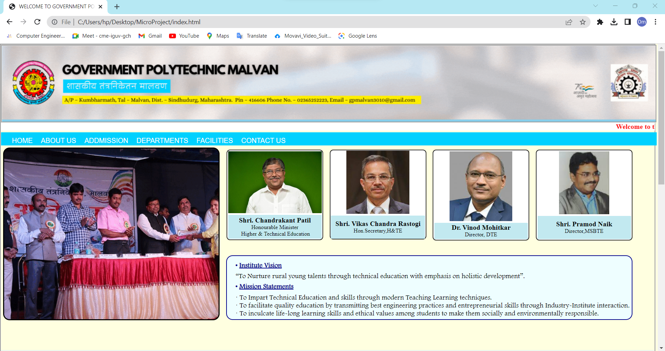

<marquee>tag

<Div> & Hover effect

Gif Image

Header

**Main Page**

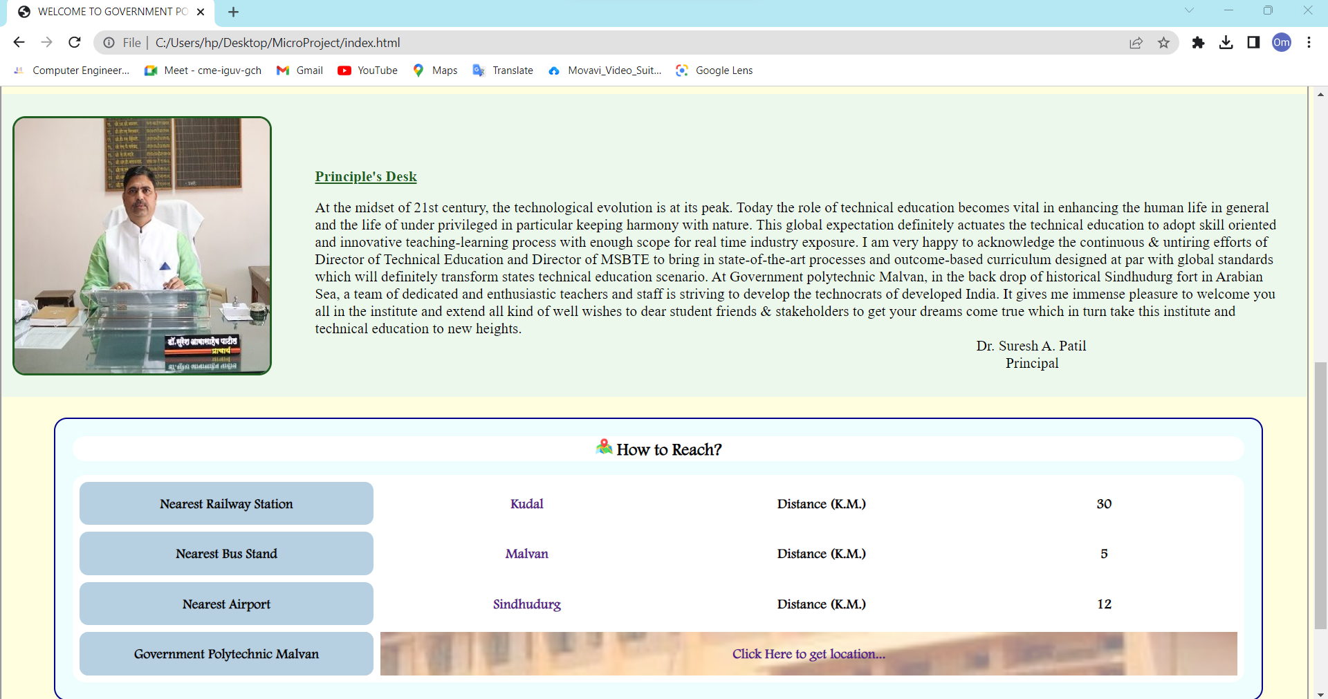

<footer> tag

Hyperlinking <a> tag

<Div>, Hover effect & <Table> Tag

<Div> & Hover effect

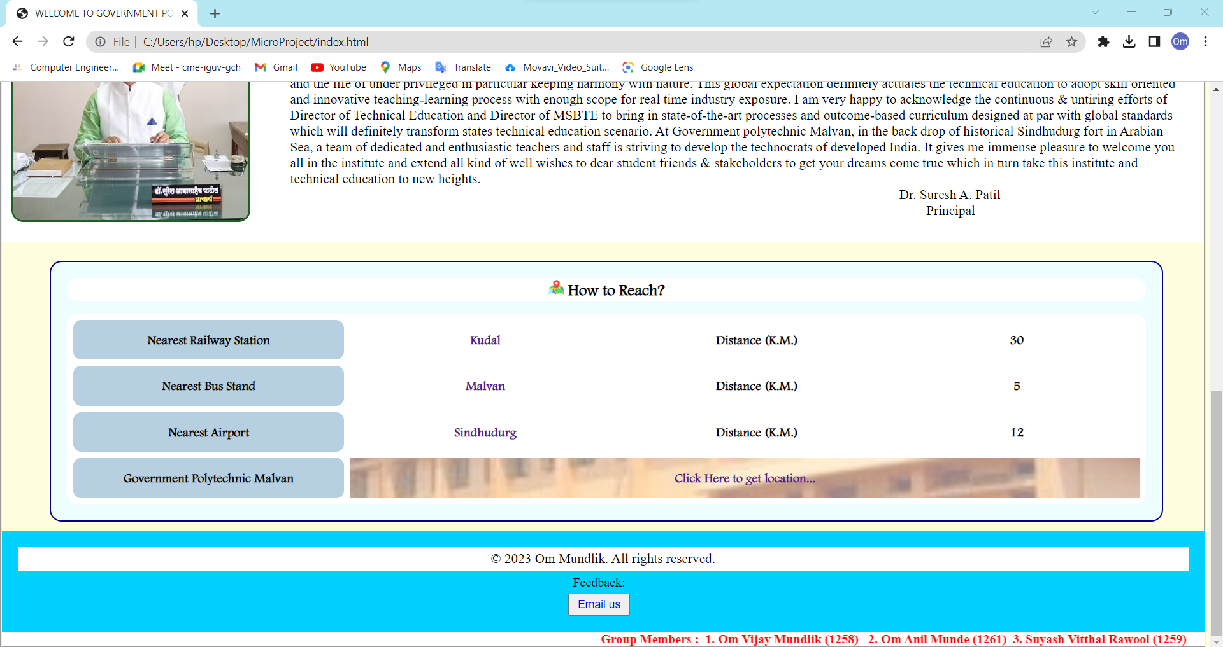

<a href=” mailto:”>

**Main Page**

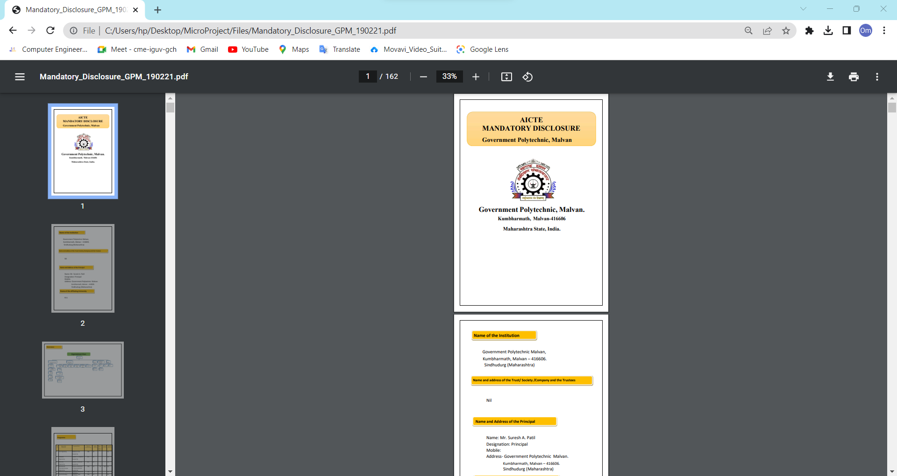

**About us Page**

Hyperlinking <a> tag

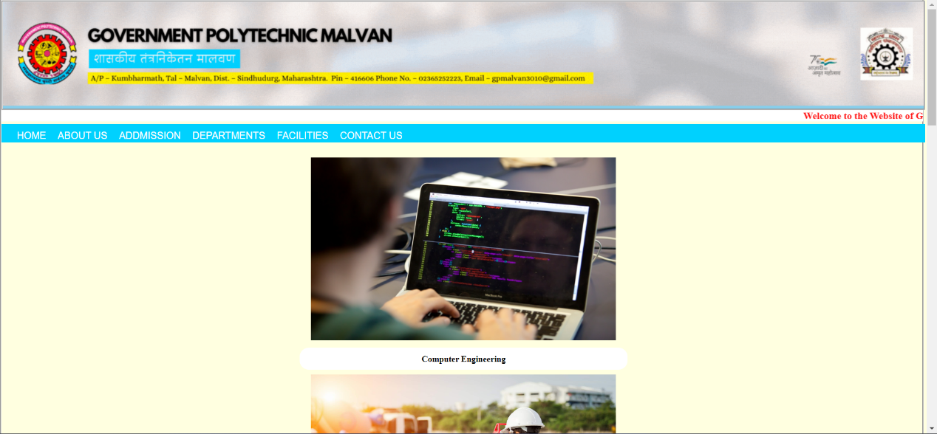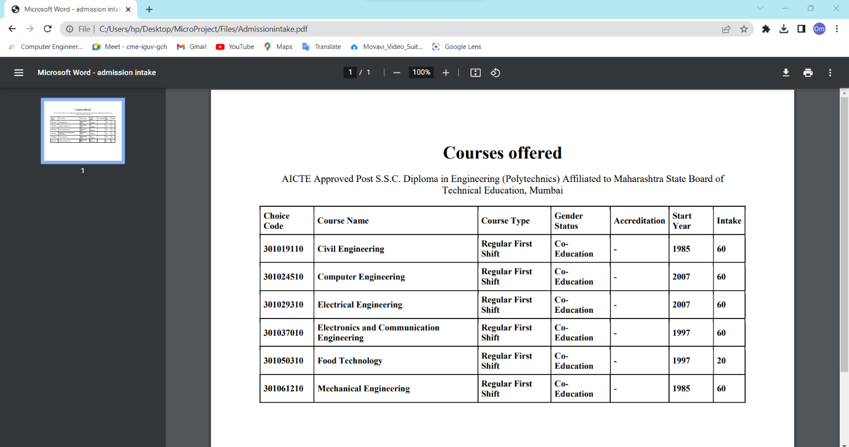

**Admission Page**

Hyperlinking <a> tag

**Departments Page**

Image Tag & <div> tag

<div> tag with CSS

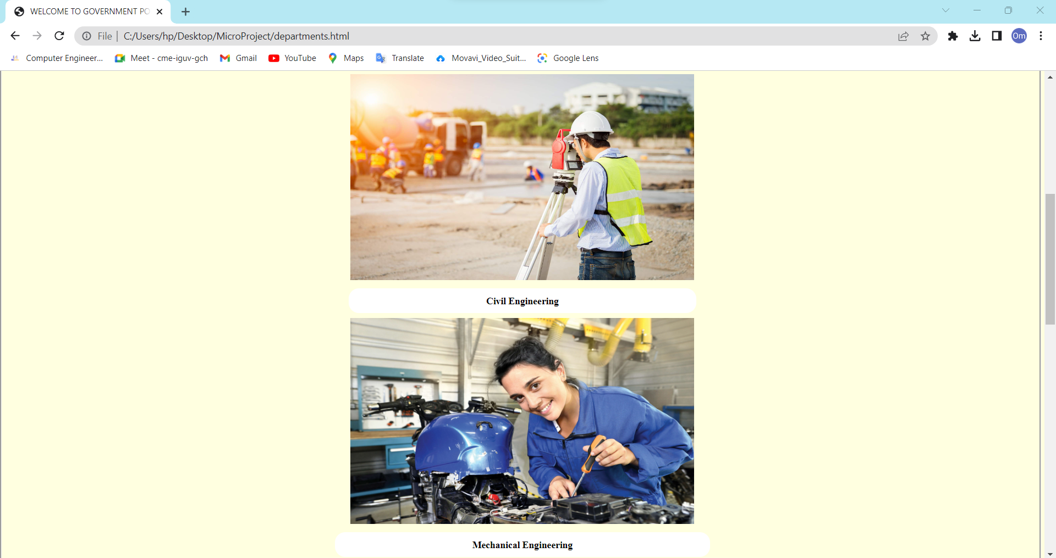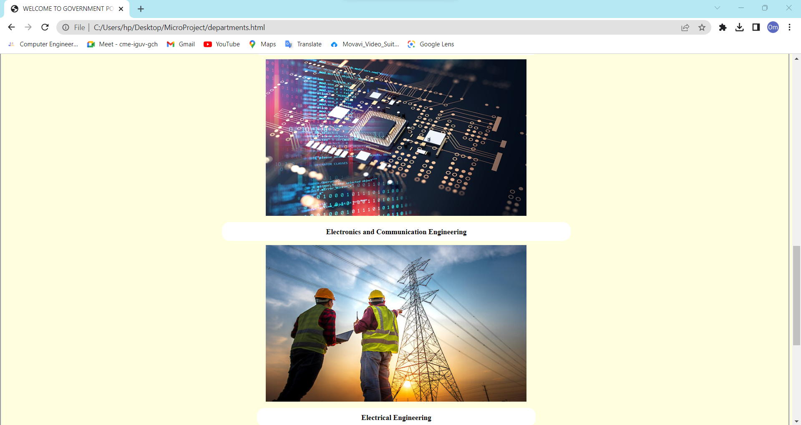

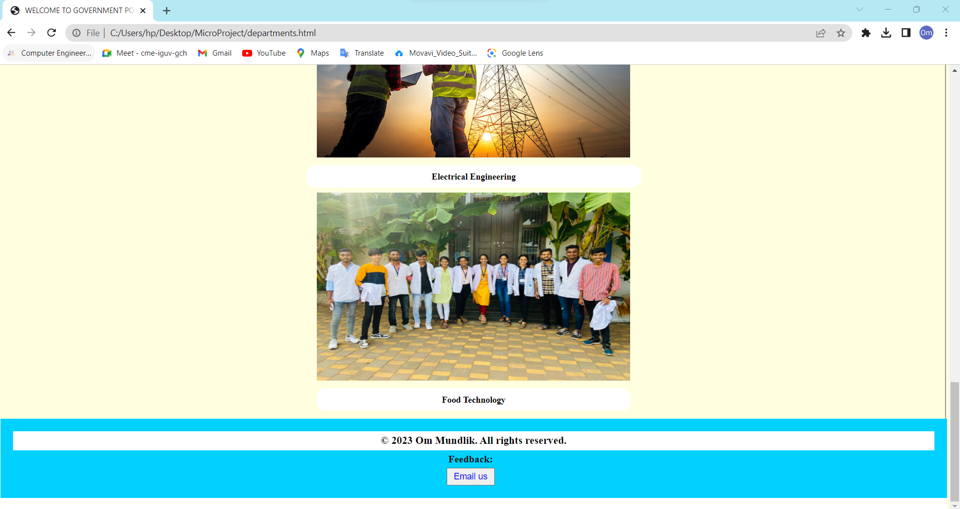

**Departments Page**

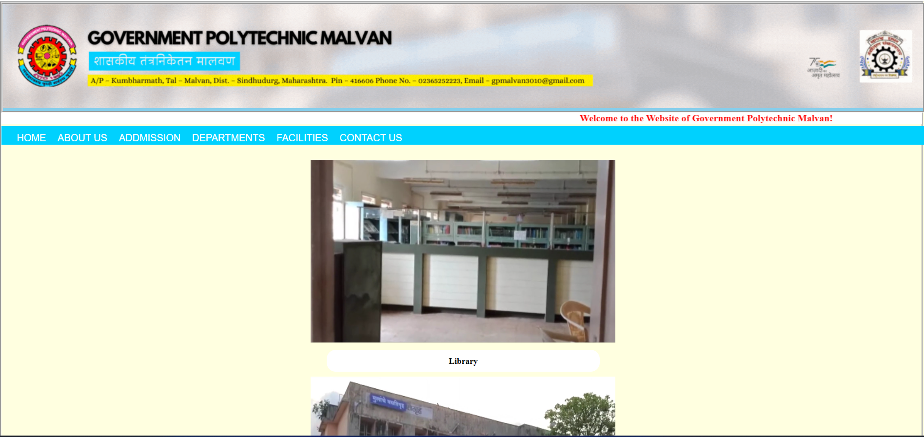

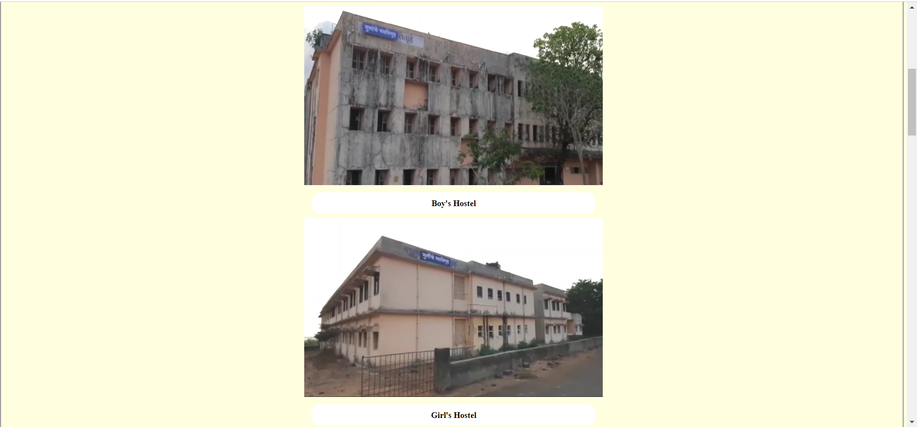 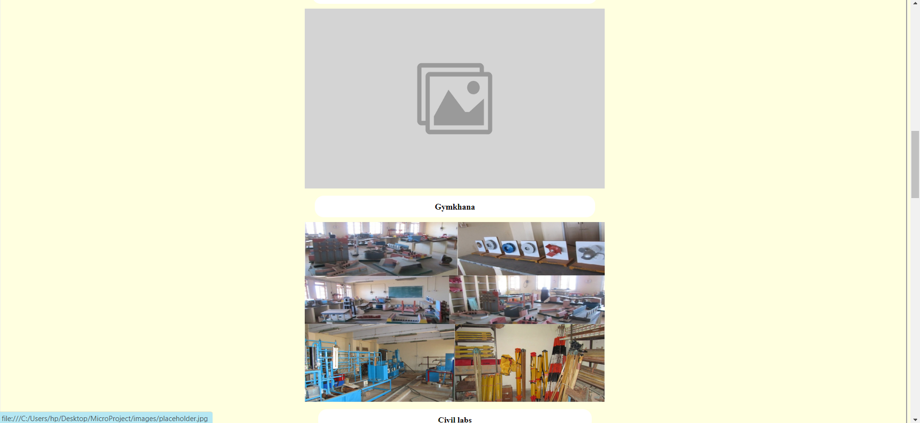

**Facilities Page**

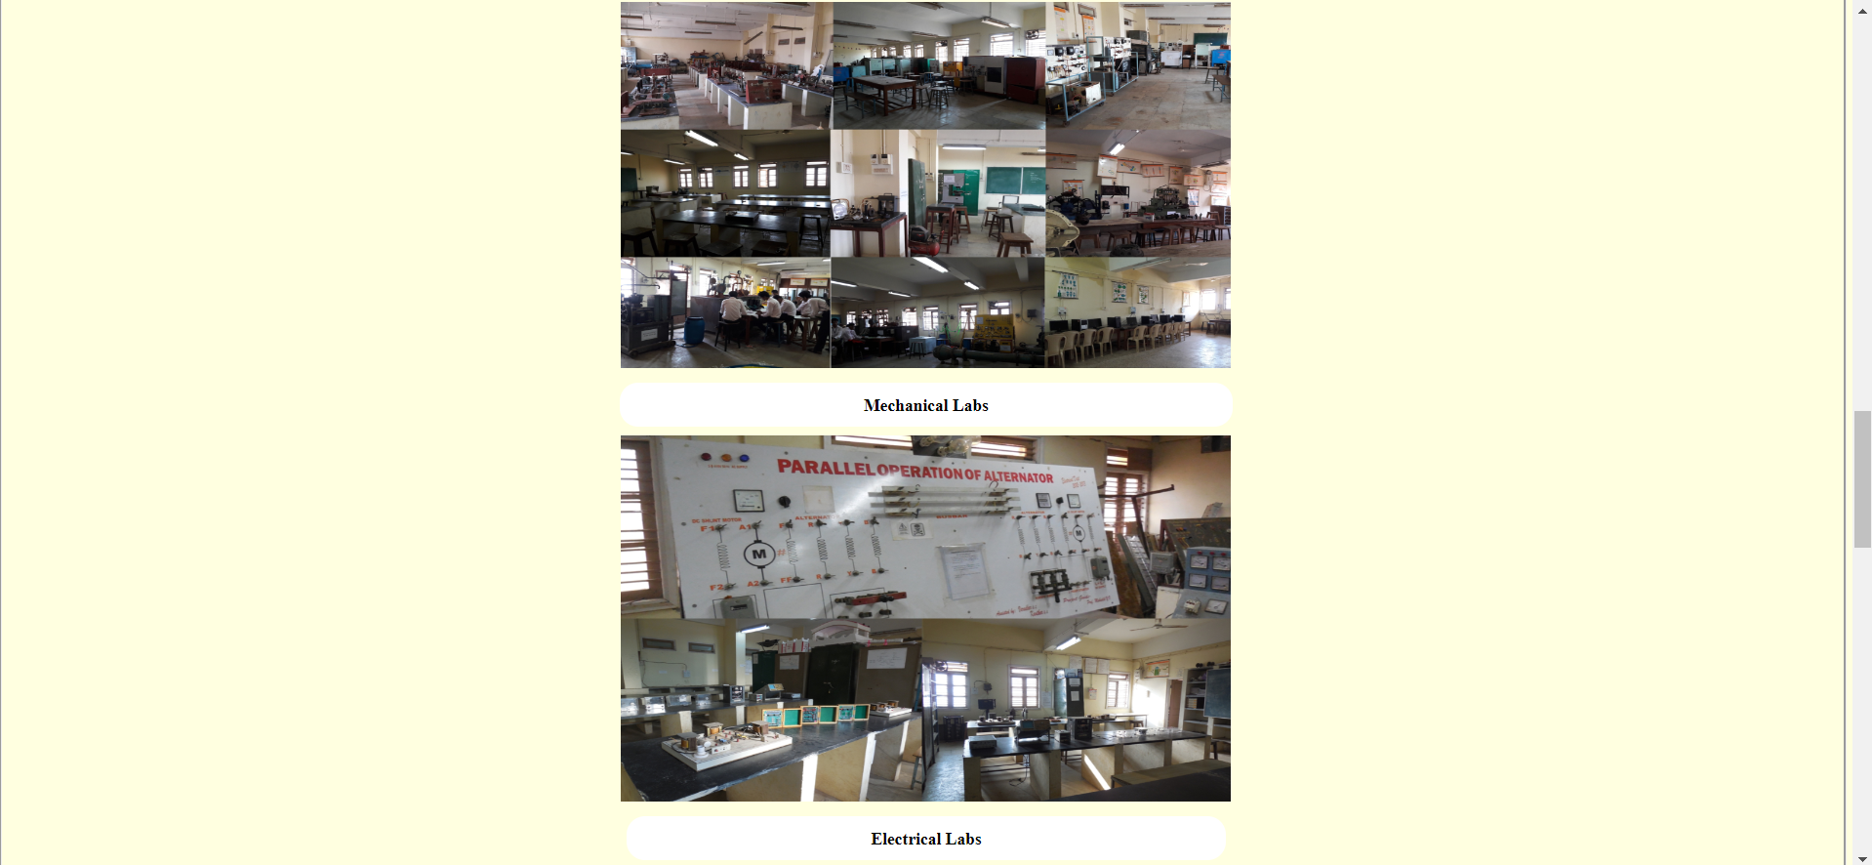 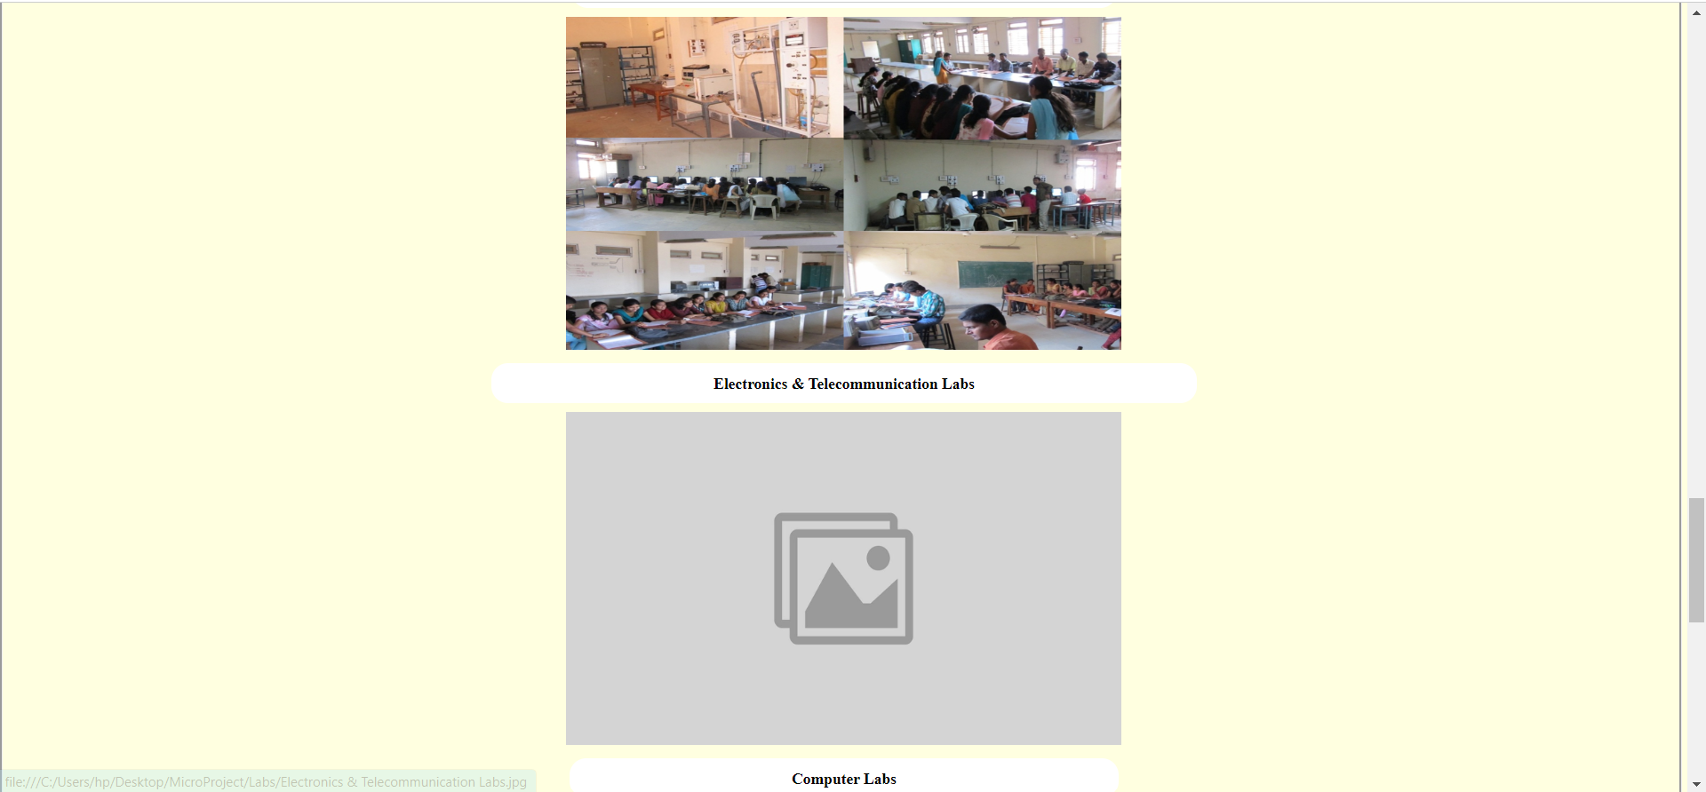

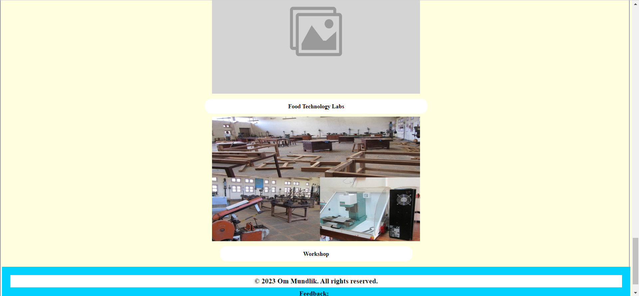

**Facilities Page**

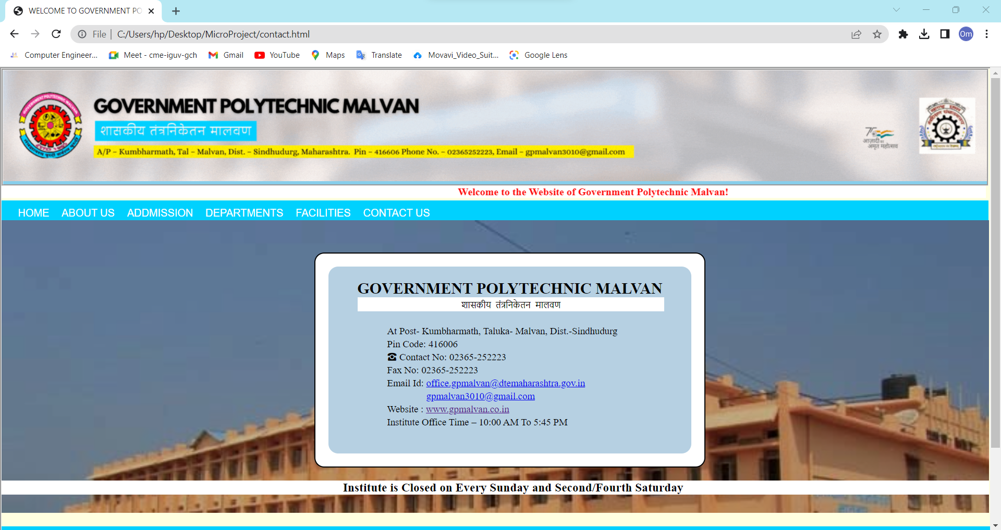

Hyperlinking using <a> tag

<div> tag, <p> tag & <h2> tag

Background-image Style

**Contact us Page**

Thank You!